1. 
2. 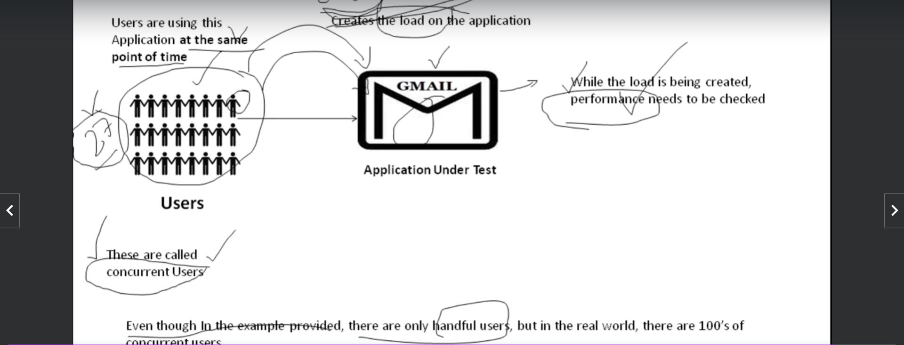
3. When load is increased on an app (AUT) and performance is tested, It is called performance testing.  
   Performance testing means to check how fast or how slow an application under load works.
4. **Concurrent Users**: The users accessing the app at the same point of time.
5. The number of concurrent users may vary depending on the app and requirements.
6. We will define the Performance Testing later when after defining the term **VUser**.  
   Popularly, it is called as VUser but, it is **Virtual User**.